WEEK 4

QUERIES FOR EMPLOYEE

=>

create database emp;

use emp;

DROP DATABASE EMP

CREATE TABLE EMPLOYEE (

EMPNO INT ,

ENAME VARCHAR(50),

MGR_NO INT,

HIREDATE DATE,

SAL INT,

DEPTNO INT,

primary key(EMPNO,DEPTNO),

foreign key(DEPTNO) REFERENCES DEPT(DEPTNO)

);

CREATE TABLE DEPT (

DEPTNO INT PRIMARY KEY,

DNAME VARCHAR(50),

DLOC VARCHAR(50)

);

CREATE TABLE PROJECT (

PNO INT PRIMARY KEY,

PLOC VARCHAR(50),

PNAME VARCHAR(50)

);

CREATE TABLE ASSIGNED_TO (

EMPNO INT,

PNO INT,

JOB_ROLE VARCHAR(50),

PRIMARY KEY (EMPNO, PNO),

FOREIGN KEY (EMPNO) REFERENCES EMPLOYEE(EMPNO),

FOREIGN KEY (PNO) REFERENCES PROJECT(PNO)

);

CREATE TABLE INCENTIVES (

EMPNO INT,

INCENTIVE_DATE DATE ,

INCENTIVE_AMOUNT DECIMAL(10,2),

primary key(EMPNO,INCENTIVE_DATE),

FOREIGN KEY (EMPNO) REFERENCES EMPLOYEE(EMPNO)

);

INSERT INTO EMPLOYEE VALUES

(9, 'ram', 11, '2020-12-15', 50000, 1),

(90, 'sam', 12, '2017-09-6', 60000, 1),

(99, 'vishnu', 12, '2016-08-15', 40000, 2),

(900, 'beshnu', 13, '2020-07-14', 20000, 3),

(909, 'meshu', 14, '2019-06-13', 10000, 3),

(999, 'jeshu', 14, '2018-05-12', 15000, 4)

INSERT INTO DEPT VALUES

(1, 'RND', 'Bengaluru'),

(2, 'NDD', 'Mumbai'),

(3, 'marketry', 'Mysuru'),

INSERT INTO DEPT VALUES

(4,'supervisor','hyderabad')

INSERT INTO PROJECT VALUES

(20,'Bengaluru','web dev'),

(202,'Mysore','Cyber sec'),

(203,'MUMBAI','ANAYLIST')

INSERT INTO ASSIGNED_TO VALUES

(9, 20, 'lead'),

(90, 202, 'cybersec'),

(909, 203, 'Analyst');

INSERT INTO INCENTIVES VALUES

(9, '2014-11-13', 3999),

(99, '2025-6-9', 9999);

select P.PLOC,COUNT(P.PLOC)

FROM EMPLOYEE E,PROJECT P,ASSIGNED_TO A

WHERE E.EMPNO=A.EMPNO AND P.PNO=A.PNO

GROUP BY P.PLOC

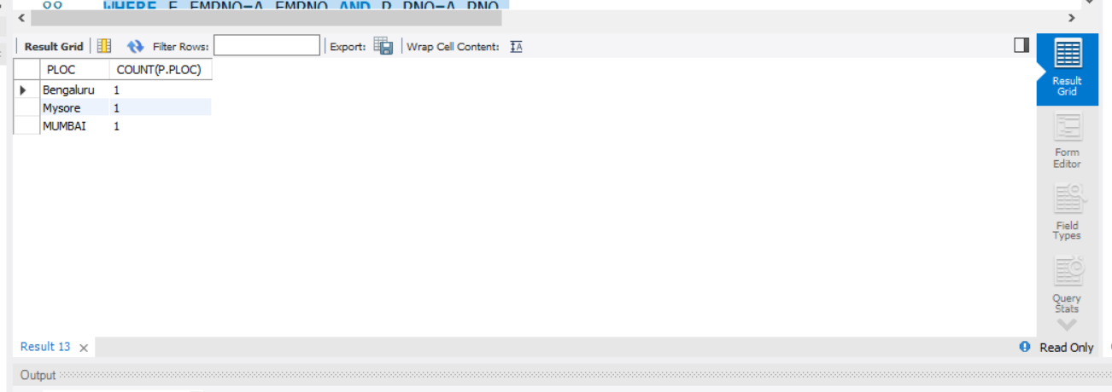

SELECT E.EMPNO

FROM EMPLOYEE E

WHERE E.EMPNO IN (SELECT EMPNO FROM INCENTIVES )

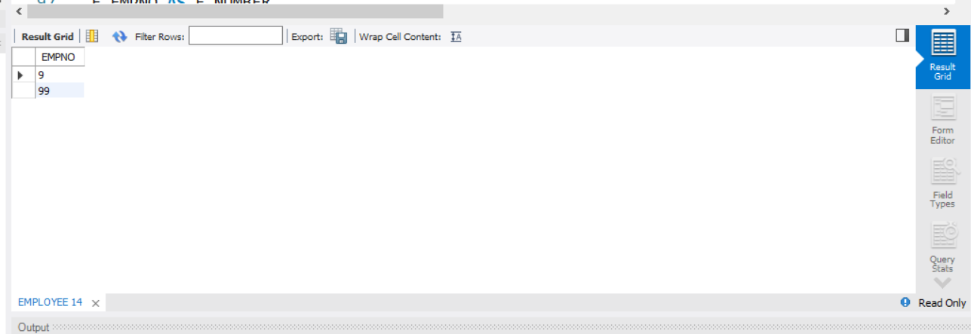

SELECT

E.ENAME AS E_NAME,

E.EMPNO AS E_NUMBER ,

D.DNAME AS DEPT,

A.JOB_ROLE AS JOB_ROLE,

D.DLOC AS DEPARMENT_LOCATION,

P.PLOC AS PROJECT_LOCATION

FROM EMPLOYEE E,DEPT D,PROJECT P,ASSIGNED_TO A

WHERE E.EMPNO=A.EMPNO AND E.DEPTNO=D.DEPTNO AND A.PNO=P.PNO AND P.PLOC=D.DLOC

